How to remove device from a group in Aruba Central

**Labels: Aruba Central**

**Requirement:**

Sometimes to make the device in-sync, we may try to remove the device from a particular group or Global view.

**Solution:**

To do this, there are 2 simple steps.

1) Only Offline devices in Aruba Central could be deleted from a group/global.

To make this happen, you want to first make the device be seen in **Offline** from **Online** in the same group/global.

2) Once the device is Offline you can delete the device form the group.

**Configuration:**

1) Use below command in Aruba device, to disconnect it from Central.

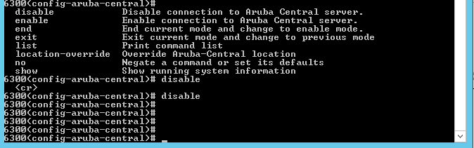

2) Now you can see the delete option on the extreme right under the Offline section, use it.

[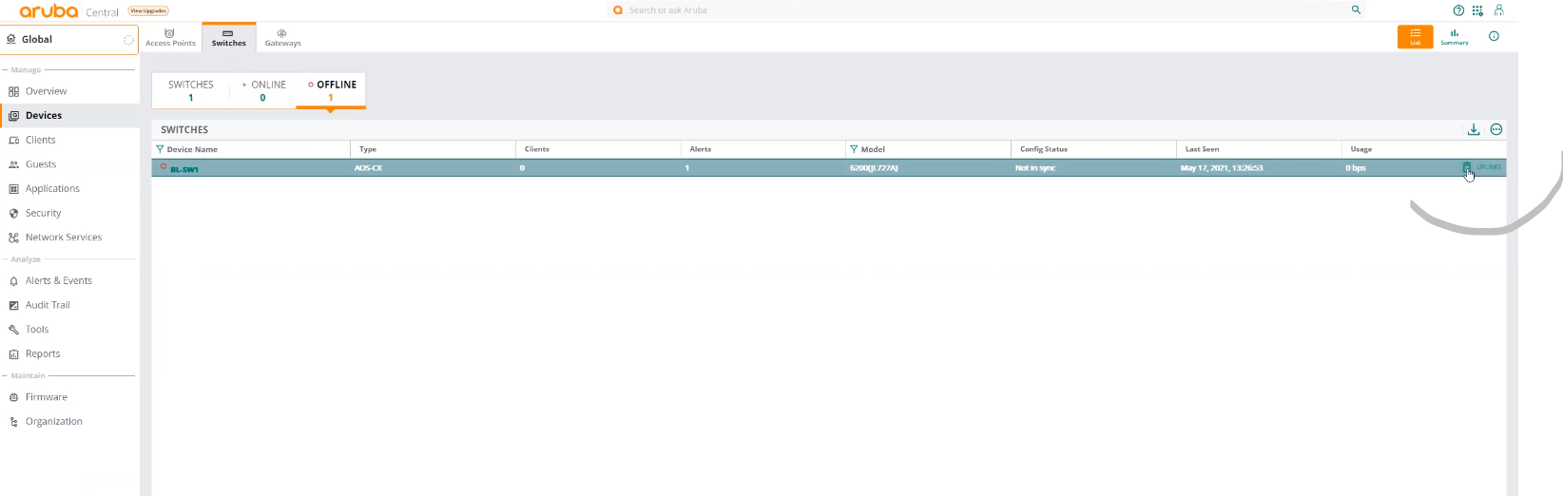](https://akb.arubanetworks.com/media/ckuploads/1110/2021/05/28/image_M617mgv.png)

**Verification:**

Now the device is no longer in the group.

Tags: Aruba Central, aruba central 2.0, #aruba central, #6300